Dayspring Discipleship Institute

505 E. Boydstun, Rockwall, Texas 75087
Mailing Address: P.O. Box 552, Fate, TX 75132

972-722-1905

www.dayspringdiscipleship.org
“ …the ministry of the Word ” – Acts 6:4

Teaching – Equipping – Training – Ministering Brenda Cox, Executive Director

January 2015 “…the Dayspring from on high has come to give light to those that sit in darkness…” –Luke 1:78-79 Newsletter

Dearhearts,
What are we to do with the winds that have blown across our world…winds of joy and winds of pain? I think on what this faded year has meant for some of you. Too many have lost children. Some have lost other family members. Others have lost jobs or other bastions of security…health, once so vibrant, has seemed to cave in under the weight of years or simply of life itself. It is here in our wind strewn debris fields that we come to sort through the pieces of God we find scattered there. What we do with these harsh winds determines, ultimately, what the winds do with us.
I think one of the casualties of a world buffered by insurances policies and contingency plans, financial planning and heroic measures for avoiding death, is that when God Himself seems not to engage in such heroism, His credentials for Godship are questioned. He seems not to have signed on with the Hippocratic oath and so, we wonder at who He is…really…and are the winds stronger than He? We wonder if justice is authored by another hand, because surely, if He is who He has said He was, this would not have been.
There are times when God is simply the shelter in our storms. A “high tower” as the Psalmist said, for us to run into. In other generations this seems to be how they saw God. In calamity they ran to Him, not from Him. My grandfather lost 7 children before his wife, Callie, died. And yet, his faith remained unbroken.
“Come unto me, all who are weary and heavy laden and I will give you rest.”…Suffer the little children to come unto me. He did not still the storm that buffeted the boat He simply summonsed Peter to come walk in the waves with Him. Coming to Him is the invitation in our storms. There are times for protection from the storms, times for the shield. But there are provisions of other sorts…provisions of strength and courage… provisions of faith. Faith is not for God and His benefit. It is for us. Faith, anchored in an unfathomable God, sustains and comforts and equips us. Faith is God’s answer for the baffling, confusing places in our lives; places of sorrow and of the incomprehensible. When logic and reason and our understanding fail us…faith, alone, can endure because faith is about God, not outcome. Hope is about outcome. Faith goes beyond outcome to God, alone. If we perish we will sill praise Him, Shadrach, Meshach and Abednego declared as they prepared to enter the furnace. Our God can save us BUT…if not, we will praise him still. Faith equips us to face the winds and walk in them still seeking God… still sinking down into Him.
It is in our places of desperation or of daring that we discover who God is. It was daring when Peter jumped from the boat. It was desperation when He sank in the waves. Both put him in a position to know faith – and His Lord – more deeply.
Walking by faith is different than having faith. All of us who have said yes to Christ have at least a mustard seed of faith. The knot’s been tied in the end of the rope and we’re at least holding on for dear life. Fear is common along this way as we come to grips with our own limitations and have not yet been assured of God’s boundlessness or of His heart. Here, many of us walk with a limp. A faith walk calls us out to places where it is impossible without God. There, He will either show up or He won’t. A faith walk usually is formed from the miry bog of fear and failure sprinkled with glimpses of glory. However fleeting, the sprinkles are enough to grow something of daring in us….or, more likely, of desperation, so that when the call comes to leave our boat, Peter’s heart in us leaps forth. The call to such a walk is tucked away in the folds of every robe of faith. We often don’t suspect it is there because of the winds that have tattered and frayed its edges.
But it is there.

Listen for the voices in your winds. There will be one that says, “Come.” When you hear it, it is your place of desperation or of daring. What you do there will determine the God you know.
I love you,

©2014 Dayspring Discipleship Institute


“Behold, I make all things New”

From the Old…Something New

Growing Through Brokenness

Watchman Nee says that a breaking is essential for the Spirit to be released in us…in our personal journey and, it seems, in the life of a ministry. The grain of wheat must first fall into the ground and die before it can bring forth fruit. So we emerge from a broken shell into a whole different world…not yet sure of how it will look, and seeing some giants out there to face. But we do it with you. We do it, led as much as we can know, by the Lord. Much remains as it has been but new sprouts are growing from the original tree the Lord planted in my heart so long ago. Our core mission as a spiritual growth – discipling - ministry remains the hub of the wheel from which everything else spokes out to the rim that moves in the world and touches lives in ways that matter.
Discipleship is, fundamentally, about living in His Word and the Word living in us. It is about living an incarnate life...Christ becoming flesh in us and dwelling among men today. Christ commissioned his disciples the last night, “If I, your Lord and Master, have washed your feet, you also should wash one another’s feet…I have given you an example that you should do as I have done.” As followers of Christ…we are to serve. As He healed the brokenhearted, so are we to do. As He set the captives free from their soulish catacombs and spiritual prisons, so is our calling. So we remain a ministry of the Word, of Bible studies and book clubs that speak to the deeper ways of our souls and of our life in Christ. We remain an agent of emotional and spiritual healing, a ministry of servant discipleship. From that…new growth comes.

A Ministry of the Word

It is in God’s word that the power to live more effectively is housed. It is through the Holy Spirit that the power is released and shows itself. Our Bible studies form the hub of the ministry wheel and emanate from Brenda’s Emmaus Bible Study Series. We are looking at new settings and ways to offer them.
The Emmaus study invites the believer to explore the road we walk with Christ and what it looks like in our lives and why. Emmaus is for those who dare to look beyond their circumstances and believe there is something more; who dare to say yes to a journey and to its mystery and its possibilities.
c

Sunday Evening Revelation Study Continues as
“Koinonia Fellowship”
5:30 – 7:00 p.m. Sundays

“Deepening our Fellowship with God
and with Others”

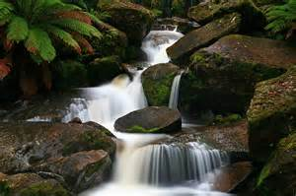
It’s the same
study of Revelation Come drink of the water…
but with a new time
and a new name to
reflect a new focus.
Koinonia is the
Greek word for fellow-
ship of and through the
Holy Spirit. It was that
fellowship of common accord we see in the first century church in Acts. It was through this Spirit- breathed community that the first century church was forged with a lasting power to overcome every perse-cution, to prevail against the “gates of hell” and to endure through the centuries. It is the spirit of love that pervaded the first century church and announced to the watching world that something Divine had invaded earth.
Once we move into our new facility, we will expand our time a bit to include a fellowship meal twice a month to be followed by the study.
We invite you to consider this time of spiritual and personal refreshment. We invite you to come drink of the water. “Whoever drinks of the water that I shall give him will never thirst…it shall be in him a well of water springing up into everlasting life.”

“The New Earth”
This last portion of our Study of Revelation stands on its own and will last 4-8 weeks.
It Includes:
- The Enduring Tabernacle
- A Place Prepared for Us
- Nations of the Eternal Earth
- The Governance of Earth

Starts 5:30 Sunday January 11
former Dayspring Chapel until we move into our place on Fannin
Emmaus Home Studies

Christy Jones will be teaching a neighborhood ladies study of volume 1 of the Road to Emmaus Bible Study this spring while Caroline Doyle will lead an 8 week study on the essential principles of our faith as covered in the Introduction to the Emmaus series.
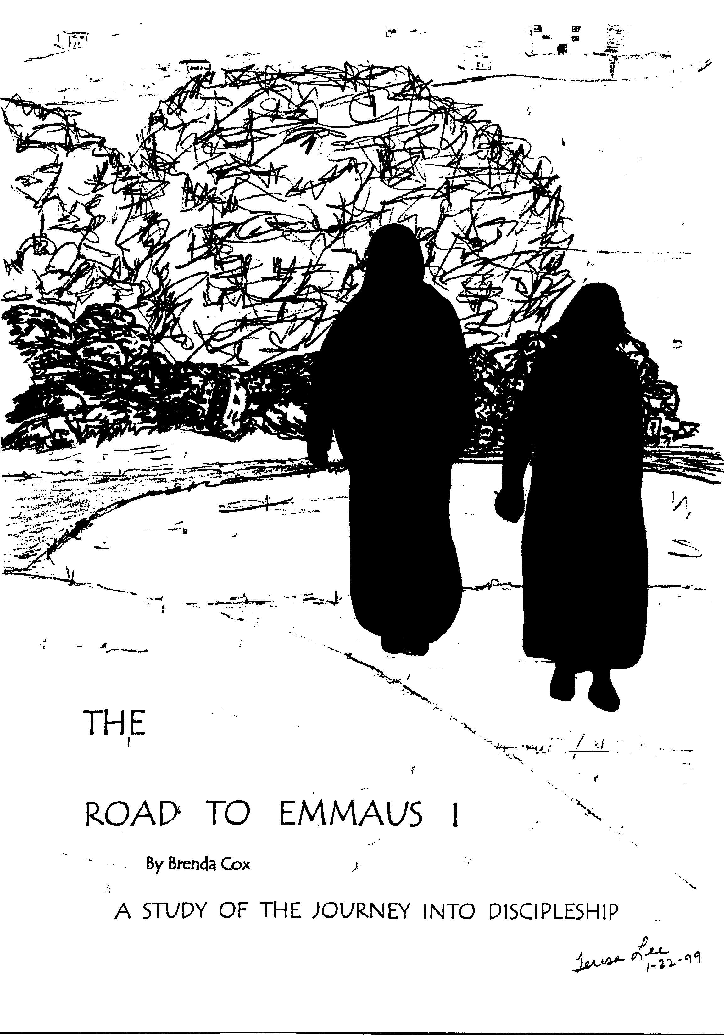
I grew up as a Southern Baptist pastor's kid having been a Christian for 50 years, and sat through many Bible studies. I thought I had a pretty good spiritual grasp of the Bible and it's principles until I went through Brenda's Emmaus study. I was surprised at how the study had an absolute life-changing impact on me with the essential Principles forever altering my walk with the Lord! The way Brenda lays out the Principles made the Bible come alive to me as I began seeing them in various scriptures virtually lifting off the page in pulsating 3 dimensional neon lights - just like numbers popped out at John Nash in the movie A Beautiful Mind!! To this day I get excited about how I can see how the Principles are woven into my daily life - correcting me and guiding me as I apply them. I believe they should be taught in every church, starting with grade school children, so they will have them imbedded into their minds as they guide them throughout their lives! Caroline

Neither the time nor place has been set yet for Caroline’s teaching. Let us know of your interest and scheduling options. Look for details in next month’s newsletter.
___________________

Brenda will also be teaching Road to Emmaus III on Sunday evenings once the Revelation study concludes.
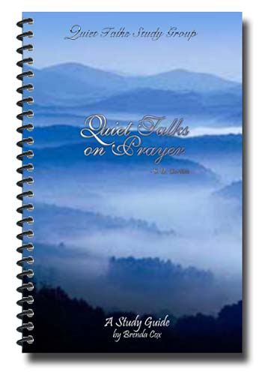

The two booklets pictured on the right are study guides Brenda has written for Hinds Feet on High Places and Quiet Talks on Prayer.
If you would like either for your personal study (especially if you can’t meet for the discussions)
Please let us know.

Cost is $3.00 each.

Home Book Study
Hinds Feet on High Places
10:00 Wednesdays in January

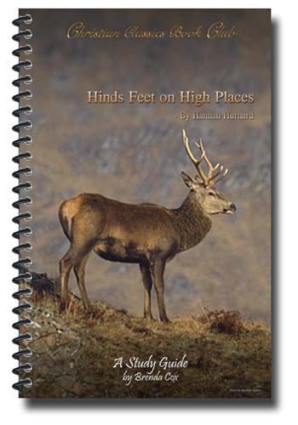
Join Pat Townsend as she leads a 5 week study in her home of this classic work in Christian literature. Few have described the nature of our journey in Christ so simply and yet so completely as has Hannah Hurnard in this small book.
Are you often baffled by God’s ways, frustrated with the twists and turns of your life, confused and sometimes angry with a God who seems remote or inattentive to your world? Hinds Feet on High Places speaks to this and so much more. Chock full of wisdom and insight, it is a captivating, probing read. Join those who are seeking to better understand a life of faith in the mix of our everyday world.
Pat has walked this path for many years and brings the experience and texture of her own faith to the journey toward the high places. You will miss a blessing if you miss this study!

Dinner Book Club
Quiet Talks on Prayer
7:00 p.m. Friday, January 23

Join Brenda for an evening of food and fellowship and discussion that challenges our understanding of prayer and may enlarge its scope in our lives. What if we are the strategic instrument in God’s activity among men? What if prayer is God’s vital tool through which He plants His will among men? What might that do to the ways of our faith and life as Christians? S.D. Gordon holds forth provocative possibilities in prayer. Come lend you voice and your thoughts to the discussion by reserving your place at the table now.
Prayer is man giving God a footing on the contested territory of this earth. The man in full touch of purpose with God praying, insistently praying – that man is God’s footing on the enemy’s soil….And the Holy Spirit within that man, on the new spot, will insist on the enemy’s retreat in Jesus’ name. That is prayer. Shall we not, every one of us, increase God’s footing down upon His prodigal earth! S.D. Gordon
Agent for Emotional and Spiritual Healing

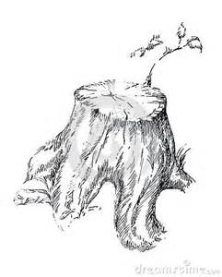
The emerging PTSD Recovery Ministry for veterans is an opportunity for many to serve. It is an opportunity for the healing of wounded hearts, setting captive places free through the array of service we are able to offer. We are all wounded by the battles of the world in which we live, but there are some who carry a greater weight…it is the weight of wars our country has asked them to fight, but wars which come home with them from foreign lands. My husband brought Viet Nam back with him. It was a piece of active duty that came home with his discharge papers and hung in closets of his soul to be taken out from time to time and worn.
Some have wondered why this recent focus on PTSD recovery has arisen. It is not because my husband wrestled with it; it is because it carries a signature that resembles God’s handwriting: Bits and pieces of flitting thoughts over the years in which I felt my counseling approach with childhood trauma could help; then the confirmation that came last year from a study on the most effective counseling protocol for PTSD. Then there was the realization that counseling, alone, could not provide a complete healing from what these veterans were dealing with. There was the need for other therapies such as massage and art which we could potentially offer, but it would require a self-contained environment. So fast forward to recent weeks and the possibility of having an exclusive facility for the ministry alone and I realized the PTSD recovery ministry was looking me in the face.
Add equine therapy. A young couple had introduced me to its amazing aspects. They were certified, but with no horses or space to do it. Then, no…they did have space and access to multiple horses. And they were available.
Add fishing. Yes, fishing. In recent weeks I had thrown out to a couple of men who love fishing the possibility of taking some of the veterans fishing as a way for them to unwind and to connect. Just a few days ago, I saw a special on a fly fishing organization that is teaching PTSD veterans how to tie flies and flyfish. The result has been significant in reducing their internal stress and chaos.
This is how God so often works, quietly placing pieces down that seem random or unrelated till one day you awaken to see something staring you in the face.
So this is the “healing agent” part for the ministry that God seems to be infusing with His will. But it can be the Servant Discipleship part for you. There are areas, here, in which you can minister.
Servant Discipleship

A Touch of Home. Though this is downline a bit because I expect this to gradually unfold, we will want to provide small special items that make our center feel like home and the PTSD vets, especially, to feel a special touch of caring love through a plate of cookies or banana bread they can take home, special coffees or teas or a book to read. Elaine Souder will be spearheading this with her gift of hospitality, but I anticipate the need for other caring hearts to reach out in simple ways that show God’s love.
Fishing. There are real possibilities for processing and healing through any form of fishing, and though I’ve already initiated some possibilities with a couple of men regarding local fishing, there is plenty of room for others to be part of this as it develops. But especially if you – or someone you know – is a fly fisherman, we particularly would need help in this area once this recovery ministry is established.
These are areas where the body of Christ can carry servant discipleship to the community in unexpected and inventive ways.
New sprouts are growing from the original tree of discipleship and of Dayspring.
____________________________________________

I Want to Thank All of You

Who Have
Faithfully Prayed for the Ministry
Helped with our Moves
Supported us Financially
and
Sustained your Interest in the Ministry

We Cherish your Continued Involvement
as we
Embark on a New Path that Carries
Increased Demands Financially
Expanded Opportunities to Minister
Broader Avenues for Teaching
and
New Vehicles for Passing the Torch of Faith
And Inspiration
Handed to us by Those who have Gone Before

