Dayspring Discipleship Institute

302 S. Fannin, Rockwall, Texas 75087
Mailing Address: P.O. Box 552, Fate, TX 75132

972-722-1905

www.dayspringdiscipleship.org
“ …the ministry of the Word ” – Acts 6:4

Teaching – Equipping – Training – Ministering Brenda Cox, Executive Director

February 2015 “…the Dayspring from on high has come to give light to those that sit in darkness…” –Luke 1:78-79 Newsletter

Proof of Resurrection
Dearhearts,
It must have seemed a dream. A distant voice piercing the cold slumber…calling him forth from his chamber of death. So Lazarus hobbled to the mouth of the tomb where His friends removed his grave clothes.
When Jesus visited his home a few days later and Lazarus’ sister wept tears of gratitude that washed Jesus’ feet, the place was aswarm with not only the committed but with the curious wanting to see this one who had come forth from a grave. And in coming to see him, they also saw the one who is Resurrection. The one whose very voice drew him out from death.
Once in the misty reaches of earth, God breathed into a sculpted form, and man came into being. Transformed by Divine breath from clay to sinew and muscle, veins and bone and skin. The essence of the Artist infused the clay with the mystery of life…A universal Wind that breathed upon earth with pulsing, creative power and bequeathed life to all the billions of clay vessels to come.
And then, 2,000 years ago…a second Wind. The breath of God infusing, not biology this time, but spirit into clay. Not just life into these animated figurines … but holiness. Resuscitating what had died in us so long ago. Man…now holy. Now carrying a part of heaven in his soul…if he cared to. In the beginning, life had nothing to do with free will, coming to us unsolicited as gift. But resurrection does. Holiness does. This sacred breath will not make forced entry into the human soul. Will not resuscitate us without our assent to a feint voice calling us out from our slumber.
So we have cared to, you and I…as believers. We have said yes. Heaven’s tabernacle has come down to us and ports around here on holy wheels…ours. Made flesh once more, the Divine moves among men. But are people drawn to us to see a resurrected life? A life that, infused with the Spirit, overcomes what earth hurls at us? Overcomes it in undaunted faith…in unyielding insistence upon goodness in the face of evil, kindness in the face of harshness and gentle words in the midst of harping voices and critical tongues? This is resurrection life today. This is what bears witness to the one who is resurrection and life. People will not see the One who resurrects if they do not see one who has been resurrected. We who believe have been summonsed from our soulish graves. We have been made holy. But does anyone know? Does anyone come to see us so they can see the miracle of a resurrected life? Are we proof of resurrection?
If we do not fasten our gaze on the One who walks on waves, others will not see an uncommon life…will not see one who walks out there in the storms with Christ but will, instead, see one who sinks in the froth that has captured our gaze. We will look as they do, and people will not guess we have been brought forth from the dead. Will not guess we carry holiness in our soul.
A resurrected life may grieve, but it will not despair. May be cast down, but not destroyed. May be wrapped in grave clothes, but will not remain in them. May be pressed down to the ground, but will make its way to the light to look for the Christ whose voice calls. Calls through our grief or brokenness. Calls in our lostness and confusion…Calls.
Resurrection life carries a tenacity that will not yield to rancor or divisiveness, or paranoia; will not yield to a critical spirit. Will, instead, speak of the hope that lies within. Will, instead, think on those things that are good and noble and true. In resurrection life there is no place for things of the grave…for voices of the dying. We are not dying but living…ever and forever.

Resurrection life carries an endurance that will not succumb to a frantic earth. We are not from here any more. We have been resurrected. Our clay has been transfigured. We are spirit now and sacred voices call to us, still, to live and breathe and walk in the Spirit of another realm.
I love you,

©2015 Dayspring Discipleship Institute

Dayspring’s “Fannin House”


Moving In….

As we prepare this newsletter we are in the middle of moving into a cozy new ministry home. Dozens of people pitched in with muscle and money, with prayers and packing, loading and unloading, with trucks and moving companies, with repairing and fixing, cleaning and organizing, arranging and re-arranging…and re-arranging again. And…again. Some spent hours while others spent days helping with our moves.
And We are so Grateful to All
There simply isn’t any way we could be in our house on Fannin street without all who have given as you have, and there isn’t any way to adequately thank you for all you have done. Though it may still be a bit messy with boxes and things, we are open for business!

Koinonia Fellowship
Revelation Study: The New Earth
5:30 Sunday Evenings

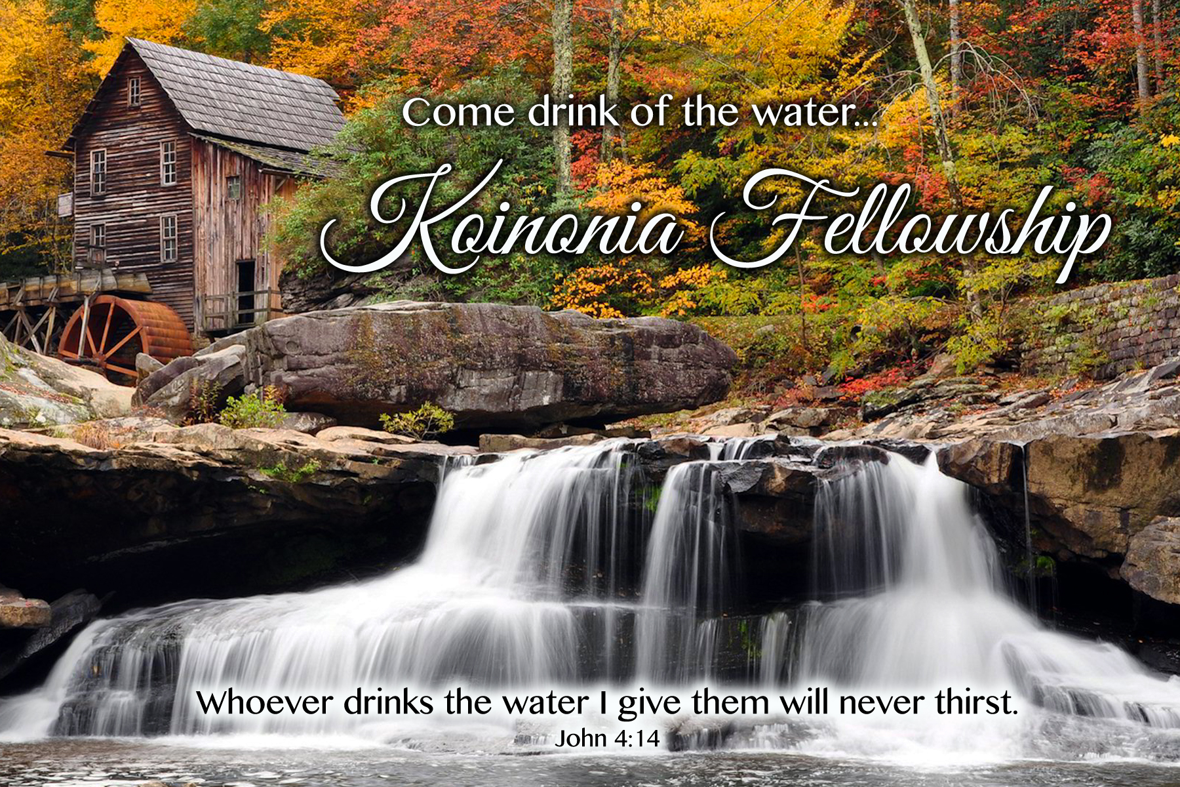
Our Revelation Bible study led by Brenda continues its focus on the New Earth, pulling in large portions of prophecy from the Old Testament as well as Revelation 21 and 22. It will be meeting in the Fannin House for the first time beginning Sunday, February 8, at 5:30 following a time of fellowship.
Please contact us for details if you would like to come.
______________________

Please Note our mailing address
presently remains
P.O. Box 552, Fate, TX 75132
though our physical address is
302 S. Fannin St. in Rockwall.
___________________
Book Club News

Dinner Book Club

Thirteen men and women gathered around Gay Bostick’s table for soup and cornbread to discuss S. D. Gordon’s book on prayer last month. Quiet Talks on Prayer paints a simple, compelling picture of prayer that led one person’s observation, if this is true it changes everything and if people understood it there wouldn’t be just 3 people showing up for prayer.
Our discussion of Quiet Talks will continue at a second dinner around the first of March. If you did not attend our first discussion but are interested in coming, please contact our office at 972-722-1905. We have a few books available as well.

Home Book Studies

Hinds Feet on High Places. “What a journey it was! Each Wednesday morning, a group of women met at Pat Townsend's house to discuss the next chapters of Much-Afraid's journey from the Valley of Humiliation to the High Places, the Kingdom of Love. As we journeyed with Much-Afraid, we shared our own journeys with tears and laughter and nods that said, ‘I've been there too.’” We are so grateful Pat has led them in this journey through one of her favorite books.
The Vision of His Glory. Six or seven women have moved from the parlor to Patty Stefani’s home where she and Jaynie Lamb lead the discussion of Ann Graham Lotz’ book on Revelation.

Wish List

It has been suggested that we create a wish list of items needed in our new place. So we have decided to provide one here that covers both small and larger items should you want to help.
- Convection Oven
- Kitchen cart
- Storage benches (inside and outside)
- Hobby Lobby gift cards for ptsd / art therapy supplies
- Kouric coffee pods
- Teas / tea bags / sugar cubes / napkins

