Dayspring Discipleship Institute

302 S. Fannin, Rockwall, Texas 75087
Mailing Address: P.O. Box 552, Fate, TX 75132

469-338-5191

www.dayspringdiscipleship.org
“ …the ministry of the Word ” – Acts 6:4

Teaching – Equipping – Training – Ministering Brenda Cox, Executive Director

March 2015 “…the Dayspring from on high has come to give light to those that sit in darkness…” –Luke 1:78-79 Newsletter

Fixer Upper
Dearhearts,
There is a convenient view in our American fundamentalist church that, unlike any other generation in church history, we will be spared the persecution of the end times. What this allows us to do is become lazy and to focus on all the wrong things. It allows us to dance on the Titanic as the band plays. The problem with our American church theology is that it works, partially, only within our bubble and often has very little to do with the spirit of the Bible or the life of Christ or of the real world outside our window.
Every community of believers tends to carry its own national flavor. The German church certainly was laced with anti-Semitism and a merger of church and state theology that ceded inordinate compliance to the political leader and was complicit in Hitler’s ascendancy. Our American church theology is essentially that of wealth and comfort…a Laodicean perspective, not of the urgent but of the convenient. So our focus is on “how to” Christianity…how to take what is broken and run down and fix it up…re-doing finances so we can have a savings account and no debt. Fixing poverty with the prosperity message. Fixing a long sermon with 3 succinct points. Fixing up a dilapidated soul in 12 steps. Fixing Washington with Christian politicians. It’s not that these are all bad, but we have developed our own theological dialect with the prosperity message and the prayer of Jabez, with Dave Ramseys and financial strategies and with Fox News.
The problem as a culture is that we tend to bring little discernment to these approaches…scarcely holding them up to the mirror of Christ or measuring them by the spirit of Scripture. Fox news anxiety, anger or paranoia is seldom checked as a community by being ever ready to speak of the hope that lies within us; by loving our enemy and praying for those who despitefully use us, by thinking on things that are good and honorable and true and letting it produce the image of Christ in us. We tend to bear more the spirit of Fox news than of Christ. As a culture we tend not to examine the prevailing religious trends for their spiritual veracity or to catch what they’re really saying…The widow, giving her meager all…well…didn’t she know God wanted her rich? So what was wrong with her faith…why didn’t she know the prayer of Jabez? And where was Jesus’ admonition of her for, not her lack of money, but a lack of faith that produced her lack of money? Poverty is a symptom of spiritual dysfunction.
The question for us in this mingled theology is, can we do both? Can we focus on the news for hours and equally focus on the Good News? The news of Christ crucified? Of Christ risen? Of laying down our lives for this friend? Of leaving all to follow Him? Can we have double vision and still see clearly? Can we focus on the world out there and the world within with equal intensity and devotion?
Christ has told us in Matthew 6 that it is impossible. That mingled theology is mangled theology.
And we live in our American bubble while all the world unravels.
When we create a virtual reality of pre-trib rescue, we see no need for urgency or preparation; after all, we’ll be fine. We hear no call for spiritual poweress…the call to be living our faith as though we would be asked to be players in the last days. To be His servants in the real world. The problem with the American religious dialect is that the prosperity message doesn’t translate to the suffering church of Africa or Korea. The prayer of Jabez doesn’t apply to the persecuted church of the Middle East, and pre-trib safety doesn’t apply to those 21 Coptic Christians who were beheaded on the shore of the Mediterranean with the name of Jesus on their lips.

I love you,

New Dayspring Phone #: 469-338-5191

©2015 Dayspring Discipleship Institute


The Pastry Porch
“Open for Business”


We hope you’ll drop in for a visit. Meet a friend for tea or coffee, for a board game or for prayer or study. When it’s cold there’ll be a crock pot of soup waiting for you. Read in the antiquities library or sit outside on the deck when the weather invites you. Our doors are open, the coffee pot’s on and we are eager to see our friends or strangers in need of welcome.

Gay’s Ministry Nook
We are so thrilled to be in the new Dayspring location. Along with that I am able to put into action a dream I have had for a year or more…to have a global shop that helped sustain artisans from various places around the world. Even though it is tiny at this point, I have started carrying two different types of items. Woven items from India (JOYN) and chocolate bars from Madagascar (KYYA chocolate).
When my daughter and son-in-law moved to Bentonville, Ark. to do a church plant, the folks there were passionate about the plight of the poor around the world and were doing something about it. JOYN was started by Dave and Mel Murray in Rajpur, India, who moved there in 2010 with their two young sons with a passion to change the lives of the people living in poverty. Many of whom grew up begging on the streets and had no skills, education, identities or even birthdays. They suffer from hunger, abuse, leprosy, drug addiction and chronic illness. JOYN started out to create a sustainable business and employ as many people as they could. They not only offer steady jobs and a good work environment but a daily meal plan, education, vocational training and medical care. The marketing director goes to Rob’s church and goes to India several times a year. It is wonderful to hear first hand all the amazing things that are being accomplished there. The products are various types of bags, purses, scarves and woven items.
Another family has started the KYYA chocolate company, from bean to bar. They have relationships with local farmers around the globe and pay them above fair trade prices for their cacao beans. The beans are brought to Arkansas and transformed into these wonderfully unusual chocolate bars. 10% of their profit goes to orphan care around the world. They have adopted 4 orphaned children themselves.
So if you need unusual gifts for someone, come by and check this out. Also check them out on the internet for more details of the work they do. Gay
We are so Grateful…

…For those who continue to faithfully support the ministry and those who have even increased their giving. There are some faithful donations that no longer come in as they have for years and we thank those for what they have meant to us for so long. We are touched and blessed by all who have given over the years and for those who continue to step up to fill in the gaps and sustain the work the Lord has entrusted to us:
- Bible Studies and Spiritual Growth
- Emotional and Spiritual healing
- Lakota Sioux of Pine Ridge
- Elderly
- Veterans with PTSD
- Art therapy
- Antiquities Library Resource Center and Teaching Ministry

…“Seed” Donations
We were particularly blessed recently when two women came to Brenda within days of each other feeling compelled to give out of their lack, rather than their bounty. Both said it was “seed money.”
The one on fixed income who has long struggled at the end of each month, met Brenda on the ramp at the Fannin house in the midst of the move. “The Lord told me to get this to you today…I’m supposed to tithe my social security…Maybe this can be seed money that will produce much fruit.”
Three days later another woman who works three jobs just to make ends meet handed Brenda a $100 bill and said, “I need to do this monthly; it’s seed money.”
They are sowing seeds and expecting with their sacrifice to produce something far beyond what they have given. We are blessed by their heart and faith and their sacrificial commitment to the Lord’s work through Dayspring. We wait in anticipation to see what will spring forth from their seeds!

Dinner Book Club
7:00 p.m. Friday March 20

Join us for a continuing discussion of S.D. Gordon’s book Quiet Talks on Prayer. If we catch what he is saying it profoundly changes how we see prayer and our role in God’s purposes. Would we want a spark to burst into flame? Would we want a passion for something greater than ourselves, something we see in ages past? This book may be such a fan. Reserve your place at the table now.


Pine Ridge News

Youth Suicides Return

“Are you able to provide for the certification for our social worker?” the email from Pauletta Red Willow, director of the Emergency Youth Shelter, asked. “We have had 3 suicides in the past 3 weeks of young females ages 12, 13 and 14 years old. We are in desperate need of local services and counseling. Please let me know if this is still an option for our social worker.”
Brenda had offered that help last summer as she and Linda Palmer and Caroline Doyle visited with her at the center and inquired about counseling needs and challenges. One of their former counselors was considering coming out of retirement but needed $350 for re-certification costs.
The shadow of 53 suicides in the summer of 2012 looms over the reservation like an ominous cloud and stirs fears of another “contagion” with these recent suicides. “You usually see markers with these kids,” educator Lynette Cuny told us, “but with one of these girls there was absolutely no indicator! We’re at a loss to know what to do.” The unmistakable tone of discouragement laced Lynette’s voice for the first time since we have known her, but as we talked creative ideas bubbled up in Lynette’s thinking to use videos from the surviving siblings to show to classmates as a peer message “which should work a whole lot better than adults trying to tell kids what to do.”
We are preparing a packet of materials to send to Lynette to help teachers and other adults as they seek to guide students and classmates in not only dealing with these losses but in deflecting possible copy cat behaviors. It Reminds us of the daunting need for counseling. Our discussions with both Pauletta and Lynette have covered some creative options of remote counseling via skype and expanded counseling through the schools.
Because it is such a long shot for us to be able to sustain a counseling outreach there we have not been focused pro-actively in this area. However, the critical needs, combined with their creative, out of the box thinking, calls on us to resume actively exploring options.
We will be exploring the possibilities of creating a pilot project at the Pine Ridge school with a young Lakota woman Brenda met in her first visit who graduates this year from the University of Wyoming with a Masters in social work. If it proves viable, it could be replicated in other reservation schools.
Though still a very long shot, it may be a path through an otherwise impossible labyrinth of logistical challenges. Even in this scenario, there would be the need for a sizable fund to sustain it.
We ask your prayers regarding this and any potential support because only supernatural intervention can chart this course and only a partnership between Him and His people can fund it.
_____________________

An Evening in April

“The Pine Ridge Experience”
with Lynette Cuny

Sharing Between Cultures
Stories / Experiences / Insight
Information and Appreciation

Though the date is not yet set, we want you to know of our plans for this upcoming event in late April or early May so you may keep your calendar as open for it as possible.
Lakota educator, Lynette Cuny, will be the highlight of this symposium-style gathering as she offers first-hand accounts of the realities and experience of life on the Pine Ridge reservation. It will also be a time of sharing our experiences there and where we are headed and expressing appreciation to all who have contributed to our mission outreach at Pine Ridge.
_______________________________________________________________

Pray for Pine Ridge
The only hope for real and lasting change on the reservation is a spiritual awakening.
A manifestation of Christ so profound that a people are revolutionized and awakened to the power and possibility and hope that only comes through Christ.
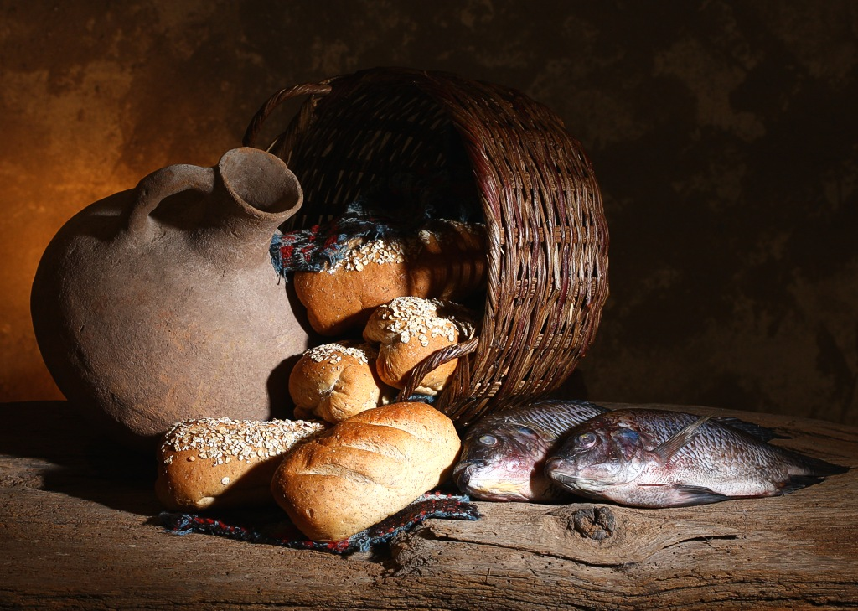
Project Hope
Summer Schedule Taking Shape

Though some details remain to be worked out our summer outreach is basically in place.
Week of July 6
- Girls’ volleyball camp
- Art workshop
- Woodworking workshop

Early September
Women’s Retreat – Sharp’s Corner Baptist Church

The Project Hope Pine Ridge Fund

is solely sustained by your gifts. Through it you have enabled those with limited funds to minister there, defrayed expenses and assisted many needs:

- Travel and lodging for Pine Ridge trips
- Heating assistance for Lakota mother of 3
- Certification expense for Pine Ridge counselor
- Gas cards for CASA volunteers
- Purchase of furniture for CASA safe room
- Self-Sufficiency workshop expenses for Partnership for Housing
- Sheets and Linens
- Clothing
- Toiletries for Emergency Youth Shelter
- Art/Craft supplies for Kyle Youth Center

Thank you for your faithful support of this fund and of our mission outreach in Pine Ridge these past 2 years.

Dayspring Movie Nights
are intended to promote thinking and discussion on topics relevant to how we are to live and how we relate to others and impact their lives.

Our Next Movie is
Frozen
And is slated for April

Though a fun and delightful movie it speaks to how life events affect us and in turn the effect our responses have on others. We look forward to reflective discussions with “Frozen”.

A Life of Prayer and Service


He died at 29 of tuberculosis. He had carried a devotion to prayer and service into the eastern wilderness to serve the Delaware tribe there. It was through his prayers that the Indians came to see him as a holy man and came to believe in his God. A great awakening came to hundreds of Delaware Indians as a direct result of David Brainerd’s sacrificial life of service to them and to God. And through his influence, the signal figures of the Great Awakening in Europe and the American colonies were impacted as well.
Jonathan Edwards suspended much of his work to write an account of Brainerd’s life of service and prayer and took him into his home to be cared for. There, he died, and shortly later Edward’s 18 year old daughter died of tuberculosis contracted from her care of Brainerd. Upon reading Edward’s biography of Brainerd, John Wesley of England urged every pastor to read of his life.
Brainerd’s life was one of physical suffering and hardship, of loneliness and unyielding devotion to God. In the midst of this he struggled with severe bouts of depression, having expressed a desire to die in almost 30 of those dark moments. His life is a testimony to the human journey of faith and fallenness, and a triumphant life that perseveres, not in the absence of human fraility, but in pressing through to an overcoming witness of God in the midst of our struggles.
_________________________________

Listen to Brenda’s Teaching on

The Book
Of
Revelation

On the Dayspring Website
www.dayspringdiscipleship.org

Scroll down Menu panel and click on
Downloads and Teachings
(can be downloaded to your iphone)


In the House of Islam ….

“Blowin’ in the Wind” by Peggy Ruff

After three years in the Middle East my nephew and his wife returned to the States on furlough with stories of Muslims converting to Christianity that were astounding. Two men in particular had become Christ followers and subsequently led literally hundreds to Him through their small group ministries. “We help them to start simple reproducible house churches, and train them to develop leaders and start new churches themselves. We focus on obedience to the scripture and the Holy Spirit.” One of several methods of ministering to Muslims is to meet with individuals, share with them the five major prophets of the Qur’an, and explain how Christ fulfilled these prophetic proclamations. As a result, my nephew and his team witness light dawning on Muslims, who then profess faith in Christ.
“join me in praying for those who have cast their destiny with Christ at the risk of everything.”
In his book, A Wind in the House of Islam: How God is Drawing Muslims around the World to Faith in Jesus Christ, Southern Baptist missionary of almost 30 years, David Garrison, relates similar stories and gives numerous accounts of dreams and visions. Most missionaries to Muslims throughout the world speak to the power and recurrence of visions and dreams in salvation accounts. Muhammad himself attested to the value of dreams, thus providing a basis for his followers to believe in their power. Many Muslims recount dreams in which “’a being who shone bright as light’ appeared to them, beckoning them to come to him” (Garrison, p. 243). Then, when directed to Scriptures describing Christ, these people recognized Him as the One in their dreams.

Consequences for Muslims who turn to Christianity are severe: extreme persecution, including banishment from their family, extreme physical abuse, imprisonment, and even execution. For these reasons, many Muslims have turned to Christianity secretly, but others have braved the consequences and shared the gospel with others. As Garrison notes, “this reality of persecution remains the great crucible that is both proving and purifying their faith.” He urges his readers “to join me in praying for those who have cast their destiny with Christ at the risk of everything.”
So—what do we do with this astonishing information? David Garrison offers five practical ways to join in this worldwide awakening in his final paragraph:

…as we pray for Muslims, support outreach to them, minister to them, love them as neighbors, and share our faith and lives with them, we rise above the spiraling conflict and violence that occupies those bound to an earthly perspective. Soon, we find we have been lifted to a different plane of ministry. Our meager talents and abilities no longer limit us; we have taken flight. We have been caught by the wind of the Spirit that blows wherever it pleases and carries us along with it.


Garrison’s view, and that of this ministry, is that we must fight the world with weapons of the Spirit and not of the common vitriol so prevalent here and throughout the world. As a people we are to show the difference between the common and the holy. Using weapons of the world to fight the world only assures the world’s victory, no matter who is left standing on the battlefield.
Prayer and Love and carrying the Good News of Christ with our lives is the only hope a lost world has.
We seem to be entering apocalyptic days, whether these are of the end times or not.
ISIS, and the nature of its ways,
carries the malignant signature of Satan
in a manner not seen since Hitler.

On the following page
we look at the cauldron
in which these forces have brewed
and seek to make some sense
of the abrupt and shadowy debut onto the
world stage of something that extends
beyond human evil to another realm.

In the Land of Cain and Abel

Brothers Killing Each Other ….

Though Sunni and Shia agree on the 5 pillars of Islam, their essential difference lies in their view of choosing successors to Mohammed. The divide is so great that many Sunni’s do not believe Shias are true Muslims.

Sunni


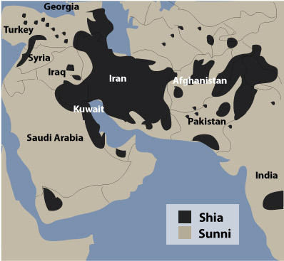
Saddam Hussein was Sunni and brutally ruled over the Shiites and Kurds. A majority of the Middle East is Sunni with the exception of Iran and, to a lesser degree, Iraq. Three vacuums were left in Iraq with our 2003 invasion and 2011 withdrawal of troops. A leadership vacuum filled initially by American personnel. A military vacuum as we dismantled their military, leaving Iraq to be protected and patrolled by U.S. troops, and, when we withdrew our troops it left an inexperienced, untested skeleton of Iraqi soldiers to replace the American military.


Abu Bakr al-Baghdadi – age 43

Known as a devout, introverted kid by his neighbors in Samarra, the ISIS leader was imprisoned in Bucca detention facility that replaced Abu Ghriab in Iraq in 2005 but was released in 2009 because he posed no real threat. As he left he told the guards, “I’ll see you in New York.” While in prison he became involved with al-Qaeda which had been formed by Zawahiri in 2003 following the invasion of Iraq.
In 2012, as an al-Qaeda leader he dispatched men to Syria to fight Assad and in 2013 announced he was merging with the other al-Qaeda affiliate in Syria to form the Islamic State of Iraq and Syria
Shia

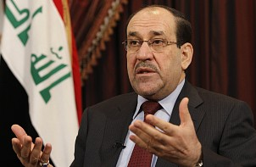

Al-Maliki replaced Saddam Hussein after provisional American governance ended. A Shia, he had no regard for the majority Sunni population and forcefully squelched their street protests. Resistance soon grew into an insurgency of extremists in northern Iraq fueled by an infusion of 1000’s of extremist Sunnis from Syria. This coalition of forces became known as Islamic State of Iraq and Syria. Closely tied to Al-Qaeda, ISIS poses a real threat to Maliki because the young, inexperienced Iraqi military, no longer supported by Americans, is unable to effectively counter the seasoned ISIS forces.

…And Whomever they Choose

From Syria and Iraq to Jordan and Eqypt, to ISIS-leaning cells in all 50 states in only 2 years! ISIS recruits from all over the world with slick videos that bait lost souls with visions of power and renown and invincibility. It is a malignant evil that suddenly appears in seemingly random places with gruesome killings the normal mind cannot
comprehend. And, yet, it summons thousands to its ranks. This is an evil that is infused with the spirit of the anti-Christ, an evil we would expect to see in the end-times.

And it warns us of the need to get our spiritual house
in order.

