Dayspring Discipleship Institute

302 S. Fannin, Rockwall, Texas 75087
Mailing Address: P.O. Box 552, Fate, TX 75132

469-338-5191

www.dayspringdiscipleship.org
“ …the ministry of the Word ” – Acts 6:4

Teaching – Equipping – Training – Ministering Brenda Cox, Executive Director

May 2015 “…the Dayspring from on high has come to give light to those that sit in darkness…” –Luke 1:78-79 Newsletter

Dearhearts,
I remember a time those many years ago when the lights from the passing car slowly made their way across the living room wall. I was up early that morning for time alone with the Lord as a tempest brewed in an inner teapot. Scriptures of God’s power and freedom both beckoned and befuddled me. Beckoned me with the vision of what could be with Him… The kingdom comes not in word only but in power….He has given us not a spirit of fear but of love and power and of a sound mind…I have come that you might have life and have it more abundantly. And then Paul spoke of the “glorious liberty of the children of God.” In my 20’s those words had been almost intoxicating…until. Until they didn’t work. Then came the bewilderment that soon morphed into a fear of betrayal. Betrayal of their promise. Are these words a lie? They sure aren’t true for me. And yet…no one else I knew seemed any more empowered than I…or any more free. Any less in bondage to human frailty and failure.
So where was the abundance? Where the freedom? Where the life of power?
Over the years since that morning of wrestling before God and with my own aspirations and dashed dreams, my pursuit has been for the illusive God of power in human cloth. What I have come to discover through other lives lived far better than my own and yet, born out in the laboratory of my own soul, is that the Holy Spirit fills old skin with the heady new wine of freedom and love and the power of a changed life. But the Holy Spirit can do this only through our consent. And it is a consent to the painful meddling of a Divine Intruder who will not stop pilfering our soul until our consent yields or becomes encased in an impenetrable chamber.
It is a journey of Surrender, yielding my own version of how something should look to His. Yielding my sense of justice and fairness…my plans…to Him. Moving from what God can do for me…to what He can do through me.
The great displays of power in Christian history have come when people made themselves available to God on His terms. Hudson Taylor, Oswald Chambers, Amy Carmichael, Watchman Nee, Teresa of Avila…
Only as I come to trust in Who He is, does how He behaves no longer bother me. It is only then that I can move from letting my circumstances define God to letting God define my circumstances. Only then do I no longer live imprisoned in my questions of why or how and move into a life of “Yes!” So how does the roadmap to His illusive power look?
Seek Truth wherever you find it...it will Always lead to God. It will shatter many of your images of God and reveal your false gods…but it will show you, if you let it…the True God.
Know there is a difference between Facts and Truth. Facts can be used to manipulate. Truth never can. At the heart of most gossip and backbiting is some morsel of fact. But facts are not truth and are not nearly so important to God as is truth.
Knowing the Truth will set us Free…But only if our heart knows it. Head knowledge of truth may only serve to further our bondage…which is what I was experiencing in my twenties. Only as my heart believes the truth can places in my soul be set free.
Know that wherever I am in bondage, emotionally or spiritually, it is because I am believing something to be true that is not true. Asking God to show me where the lie is that I am buying into may be the only way to find it. There must be a standard for truth outside my own emotions. Lastly --
Emotions do not register Truth. They register my perceptions of truth. All my life my emotions have registered complaints against me and they become a point of agreement with Satan’s deception and bondage.
When the headlights slowly move across the wall of your soul some dark night…remember the truth of who God is…and pursue it until you fall into His arms.

I love you,

©2015 Dayspring Discipleship Institute

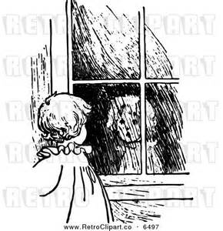
“Reflections”
Art Therapy and Art Classes
Begin May 18

Our ministry of art therapy returns this
month after a year’s break and will include regular art classes when the interest warrants. Both formats will be offered for both adults and youth on Monday and Wednesday mornings from 9:00 – 10:00 and 10:30 – 11:30. Afternoon and/or evening classes can be scheduled upon request. Please contact the ministry office at 469-338-5191 to register or to enquire.
We are excited to be able to offer art in both formats again as Elaine Souder brings her gifts and perspectives to the table:
“We alone, out of all God’s creations, are the only one that He chose to give the ability to deeply think and to truly feel. Along with this ability comes the natural gift of self-expression of those thoughts and feelings. Learning to let ourselves sit still long enough to begin that expressive process is the part that He left up to us. Our world is so busy, our lives so complicated, and the blessing/curse of the Internet has added so much to that busyness. God calls us so many times in the scriptures to be still, to wait, to listen for Him. My go-to scripture when the world closes down around me is ‘My soul, wait in silence for God only, For my hope is from Him.’ Psalm 62.1 NASB
In 1 Kings 19:11-12 (NKJV) God’s revelation to Elijah seems to parallel the strong distractions in our lives and how waiting and listening might serve us well. ‘And behold, the Lord passed by, and a great and strong wind tore into the mountains and broke the rocks in pieces before the Lord, but the Lord was not in the wind; and after the wind an earthquake, but the Lord was not in the earthquake; and after the earthquake a fire, but the Lord was not in the fire; and after the fire a still small voice.’
God is ALWAYS there, always close, but we don’t always hear Him. It is in this being still that the whispers of God to our souls are heard and felt. It is where He meets us and where we also meet ourselves. Reflection on God is where true joy is found and reflection on our inner selves is where healing begins. Peace follows healing and as Thomas Merton said, ‘Art enables us to find ourselves and lose ourselves at the same time.’
This true reflection and allowing ourselves to use our gift of creativity is the foundation of the art classes offered at the Dayspring Home. We invite you to join us as we seek God and peace through the creative process.”
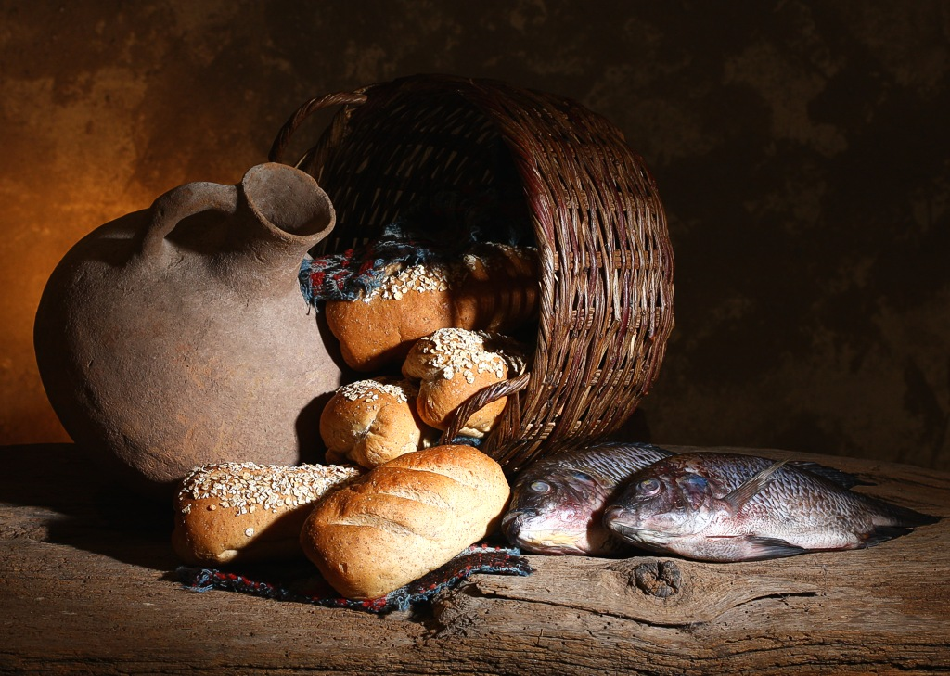
Project Hope Mission OUtreach
Two Trips Planned

Though it’s taken a bit of time to get the dates worked out, we are now scheduled in Pine Ridge for the third week in July and following Labor Day weekend in September.

July 20 – 22
Volleyball Camp Plus
Art and Writing Workshop

Our third annual girl’s volleyball camp will be held Monday through Wednesday beginning July 20 in the village of Pine Ridge. Rebecca Drummond leads the team again this year. At the same time, we are seeking to reach out to a larger community of kids who may not be into athletics by offering a combined art and writing workshop. Elaine Souder and Peggy Ruff will team to combine both art and writing in a single workshop for middle and high school students.
We are also working to try to iron out the logistics of conducting a woodworking class there at the same time as the volleyball and art. We hope to be able to update you next month on our efforts.

Sharps Corner Women’s Retreat
Our September trip takes us for a second time to Sharps Corner Baptist Church. It was a very special experience last year as those who were on our team remain in contact with some of the women who attended the retreat. We look forward to seeing them again.

As we consider our Pine Ridge Ministry
we are so mindful that it simply is not possible for us to do this without your help. We are so grateful for the amazing ways in which you have given so generously so that this outreach of love and hope to the Lakota people might one day bear fruit in their hearts.
Our deepest gratitude to you all.

Ministry at the Dayspring House Taking Shape

A Quiet Place to Come and Be
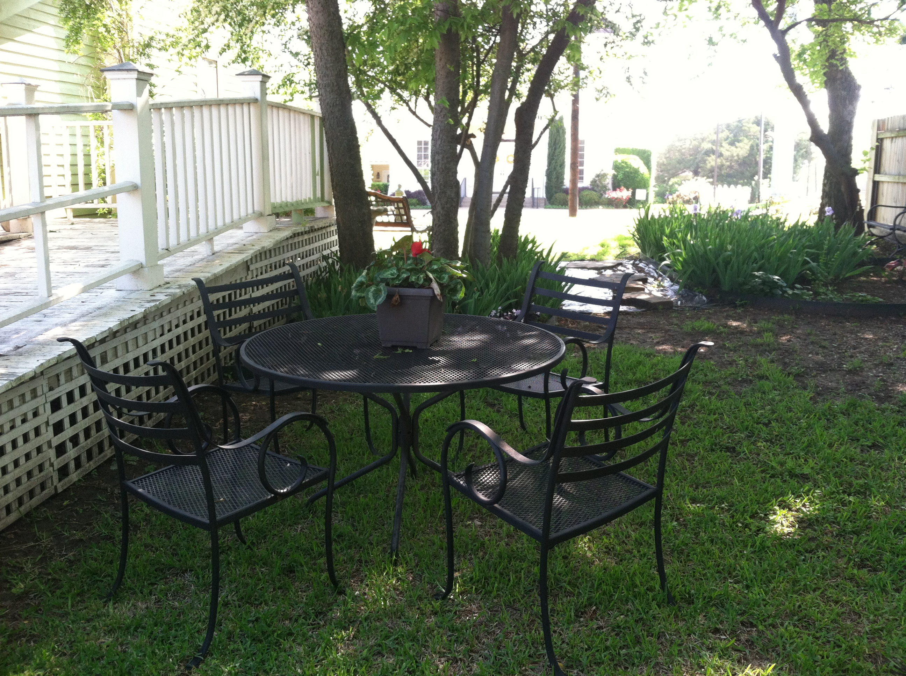

The side yard of our new home is quickly becoming garden-like as Gay and Caroline rush out in spare moments to exercise their “gifts” and plant and create a new garden area. For those who come for appointments or who just want a quiet place to eat lunch or read or reflect, we invite you to come to our garden.

Dinner on the Grounds
“We need to do this more often”

Our first potluck dinner on the grounds was an enjoyable evening that saw the rain skirt around about 25 of us as we gathered in the side garden area. From one who was there:
“Fried chicken, potato salad, chocolate cake and home made ice cream. Couldn't ask for more but there was a lot more. Tables full of food, fellowship that only happens between people that love Christ, and the singing. What a sweet sound to God's ear. All we were missing was a brush arbor but the new Dayspring garden
was a good substitute. God was there with us.
We need to do this more often.”
______________________________

-- Please Note --

Plans for “The Pine Ridge Experience”
our symposium-type event for May or June
Are Presently on Hold due to Scheduling
complications for our guest speaker from Pine Ridge. When things are settled we will let you know.

Keeping in Touch

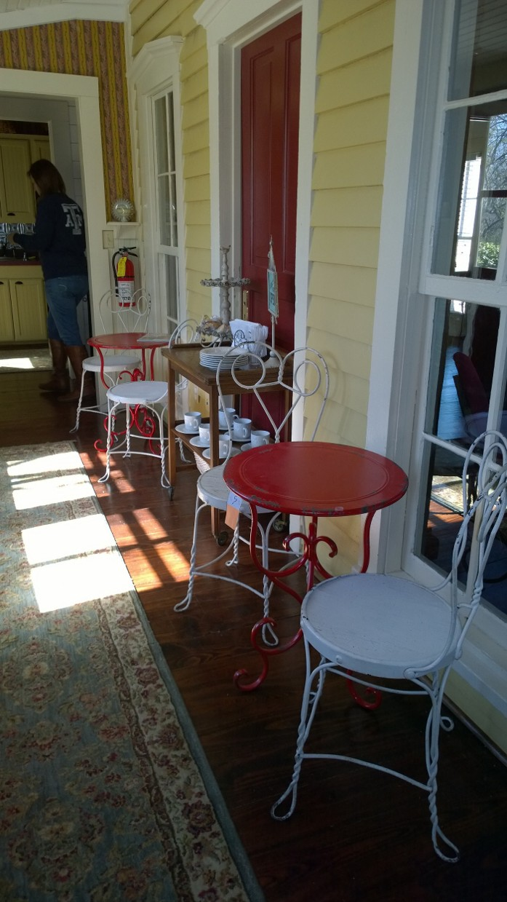
Though we’ve called it the Pastry Porch, it’s more than about pastries, or even food. Our enclosed porch is about a place to come if you want to be around people but need your space as well…or if you want to meet a friend and have soup or sandwiches, coffee or tea. Elaine calls it our hospitality area…and so it is. Whatever it’s called, the invitation is for anyone to come and sit and be welcomed, have company or just enjoy time reading in the library or on the porch or deck.
Elaine Souder brings soup or shepherd’s pie and dessert or any number of other items. Since some have asked if they can help by bringing desserts or other dishes, we ask you to contact Elaine at 214-414-9113 if you are interested.

Wish List
As we are settling in…there are things both large and small we need including…
- Picket Fence
- Ministry sign (under $500)
- St. Augustine sod ($100 approx.)
- Load of dirt
- Roman Blinds (2)
- $20 Hobby Lobby gift cards (for those who can’t afford water color journals for art therapy)
- Rare book wall display cases ($100-$200 each)

___________________________________________

Koinonia Fellowship
Road to Emmaus III Study
Begins
Sunday June 7
Cradle of the Curse

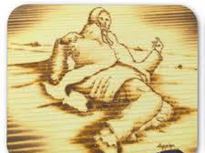
The Ghost Dance
and the
Massacre at Wounded Knee
By Peggy Ruff

For a people living in an unchanging sea of poverty, alcoholism, and suicide in which government bureaucracies, graft, and nepotism hinder positive change, there is a dark curse that blankets the once-proud Lakota people in a baffling bondage. It was here, on the banks of Wounded Knee Creek, that the collective spirit of Native Americans was extinguished. Here, the curse began.
Early in 1890, Wovoka, the “Indian messiah,” prophesied a “new earth” for all Natives. The Ghost dance began, and Ghost shirts, impermeable to whites’ bullets, were crafted and donned. Wovoka assured the Ghost dancers that they “would be taken up in the air and suspended there while a wave of new earth was passing, and then they would be set down among the ghosts of their ancestors” (p. 407 of Dee Brown’s Bury My Heart at Wounded Knee). All land with its bounty would be restored, and all whites would be buried. Satan’s counterfeit messiah promising a “New Heaven and Earth” lured and ensnared these oppressed peoples, promising them hope.
This movement spread throughout the land, terrifying the U. S. Government. By the winter of 1890, numerous chiefs had been imprisoned, killed, or self-exiled, and the slightest suspicion of Indian uprisings spurred Government agents and military regiments into action. In the bitter cold, 120 Lakota Sioux men and 230 women and children camped, huddling together for warmth. Under orders to take this band to the Pine Ridge agency, the cavalry disarmed the Lakota on December 29, 1890. A shot was fired from somewhere, and chaos ensued. The cavalry, with its four Hotchkiss guns, raked the area. About 300 of the 350 Lakota men, women and children were killed, either immediately or after attempting escape and 4 men and 47 women and children were wounded.
The Ghost shirts were shams, and the Indian “messiah” did not save the Native Americans from the 7th Calvary. The Wounded Knee massacre obliterated all hope, set distrust of whites and Satan’s foothold became a stronghold. The curse was born.
However, just as Balaam spoke a blessing rather than a curse on the sons of Israel (Numbers 22), so we will do the same. Though we don’t fully understand, we know the speaking of blessing was significant. In “The Prayer of Blessing,” on the enclosed card, we seek to come against this curse and Satan’s entrenched strongholds so that The Messiah can enter. We include this prayer of blessing should you want to join us in praying for the descendants of Wounded Knee as Dayspring serves the Lakota Sioux of Pine Ridge.
______________________________________________

A Note from Brenda --
You May have Seen the article on Pine Ridge in the April 26 Dallas Morning News on
seven recent youth suicides on the reservation that have seen the Federal government sending in teams of crisis counselors. For almost a year we have explored with people there ways to create a system to infuse more counseling resources into Pine Ridge. Tonight, principal Lynette Cuny texted she has dealt with 4 elementary school boys this week who are wanting to end their lives, and since February there is no school counselor. Last fall a tribal council member suggested we place counselors in the schools over time. This has seemed like such a long shot I haven’t mentioned it, but long shots mean nothing to God, and maybe they shouldn’t to us either.
“This past week I dealt with 2 4th grade boys and 2 5th grade boys all wanting to end their lives. We don’t even have a counselor.”

I’m wondering if a window is opening through an impressive young woman I met on my first trip there who is preparing to return to the reservation as a counselor/ social worker in the schools this fall. Because it takes from several months to a year for the Bureau of Indian Education to run a background check, we may have the opportunity to “sponsor” her by providing a support base financially and professionally. It would take around $35,000 for a year. There is no way we can do this unless God is in it and moves many of you to participate financially. So I think I’m just going to see what level of financial interest there might be. This would not be a commitment but simply a statement of reasonable intent…what you would want to give and what is realistic for you should we move forward in this area. If you are interested, please make a note on the donation card with contact info or leave a message with the office and we’ll see what God is up to. Dayspring #: 469-338-5191

